**STM32F207, Mango-M32F2, Project 구성 및 빌드 (1)**

[**http://www.mangoboard.com/**](http://www.mangoboard.com/)

**http://cafe.naver.com/embeddedcrazyboys**

**Crazy Embedded Laboratory**

**Document History**

|  |  |  |
| --- | --- | --- |
| **Revision** | **Date** | **Change note** |
| **1.0** | **2011.05.23** | **Initital 전종인** |
| **1.1** | **2011.06.07** | **문서분류 TECH추가** |

1. Release Note 2012 03 14 4

**1.1.** Base 코드 4

**1.2.** 수정사항 4

# **Project 구성 및 빌드**

|  |  |  |  |  |  |
| --- | --- | --- | --- | --- | --- |
| **(ARM,Cortex-M3) STM32F207, Mango-M32F2, Project 구성 및 빌드 (1)** | | | | | | [☞ 망고M32F2 메뉴얼](http://cafe.naver.com/ArticleList.nhn?search.clubid=15961514&search.menuid=182&search.boardtype=L&userDisplay=) |
| 전체공개 | 2012.04.12 18:45 | | | [삭제](javascript:checkLogin('delete');) |

양식의 맨 위

양식의 맨 아래

|  |  |  |  |
| --- | --- | --- | --- |
| |  |  | | --- | --- | | [http://itemimgs.naver.net/personacon/58/21/1112158.gif](http://item.naver.com/personacon/PersonaconShop.jsp?Redirect=PersonaconSub.jsp?type=itemdetail%26itemseq=1112158) | [**푸우(yhoh)**](http://cafe.naver.com/ArticleRead.nhn?clubid=15961514&page=1&menuid=182&boardtype=L&articleid=17645&referrerAllArticles=false) | | 카페스탭http://cafeimgs.naver.net/levelicon/1/1_888.gif |
| <http://cafe.naver.com/embeddedcrazyboys/17645> [http://cafeimgs.naver.net/cafe4/btn-copy-add.gif](http://cafe.naver.com/ArticleRead.nhn?clubid=15961514&page=1&menuid=182&boardtype=L&articleid=17645&referrerAllArticles=false) | |
|  | |

디바이스 링크 입니다...

<http://www.st.com/internet/mcu/product/245079.jsp>

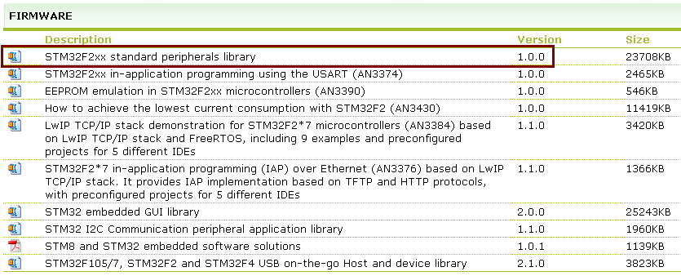  
  
stm32f2xx_stdperiph_lib - STM32F2xx standard peripherals library 1.0.0.zip  
위 파일의 압축을 풉니다.  
  
STM32F2xx_StdPeriph_Lib_V1.0.0\Project\STM32F2xx_StdPeriph_Template\EWARM  
IAR Embedded Workbench for ARM (EWARM) software toolchain (version 6.10.5 and later)  
readme.txt를 보면 위와 같이 적혀 있습니다.  
결국 최신 버전의 IAR을 사용할 수 밖에는 없어보입니다.  
  
<http://www.iar.com/>  
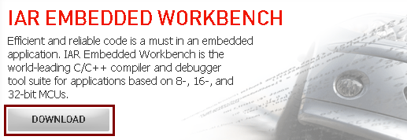  
  
30-day time-limited evaluation license:  
Fully functional for 30 days after installation with the following limitations: no MISRA C support, source code for runtime libraries is not included. The 30-day time-limited evaluation must not be used for product development or any other kind of commercial use.

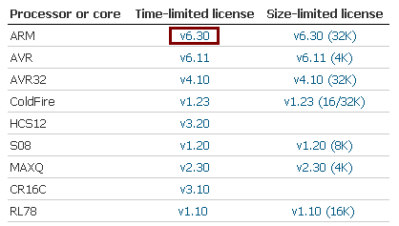  
 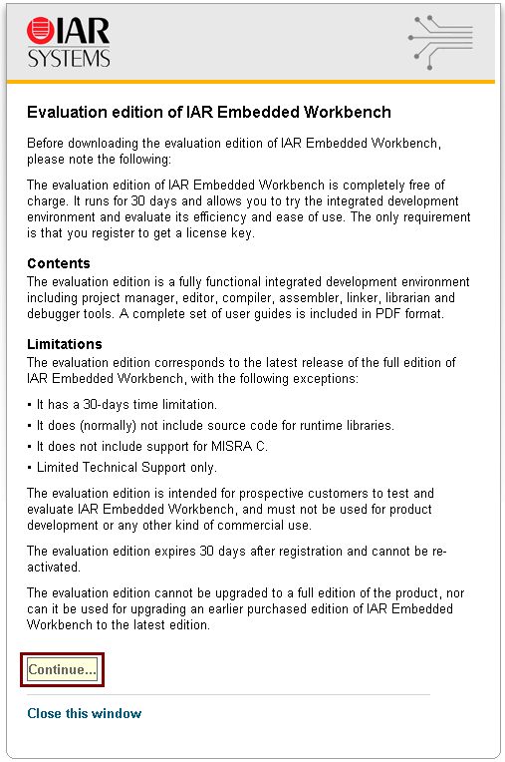  
  
이후 적절히 내용을 채워서 제출하면 메일이 날라옵니다.  
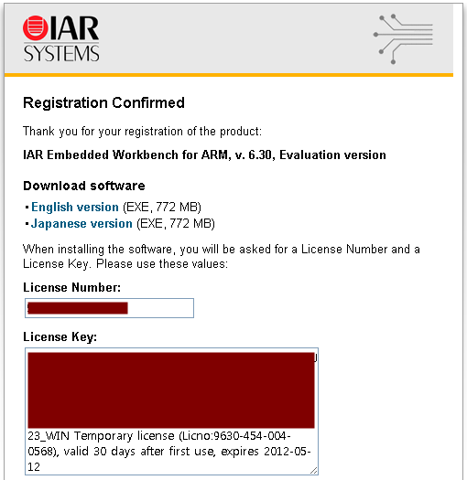  
  
메일의 링크를 따라가면 다운로드를 받을 수 있고  
라이센스 번호가 적혀 있습니다.